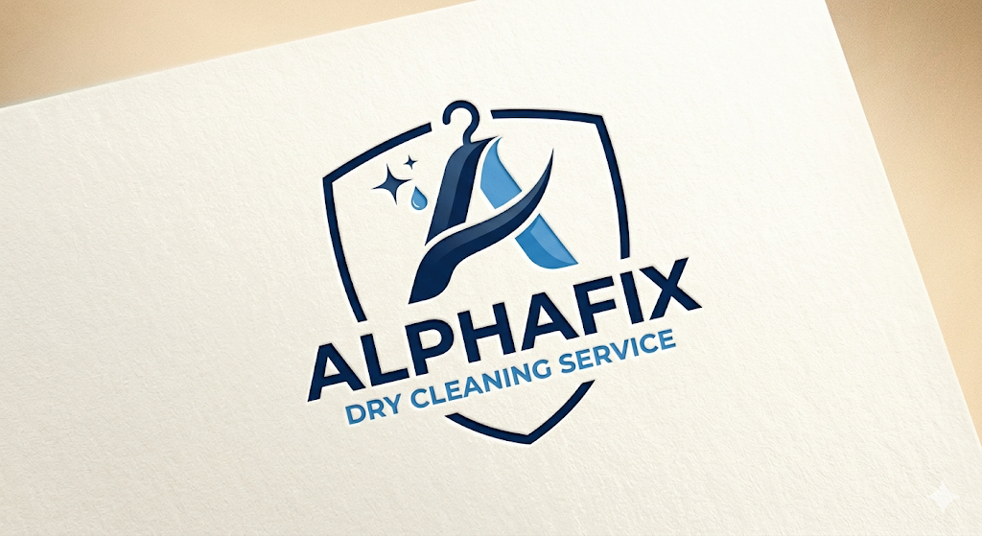
BUSINESS INVESTMENT & FUNDING PROPOSAL
Project: Alphafix Dry Cleaning Services Expansion
- OVERVIEW
Alphafix Dry Cleaning Services is a premium service provider specializing in professional garment care, fabric restoration, and textile maintenance. We are strategically positioned to serve the fast-growing residential and commercial hubs of Lagos. To meet the high volume of demand.
- CAPITAL STRUCTURE
To ensure the success of this venture, we have established a clear financial roadmap:
Committed Internal Capital: ₦2,000,000 (Already provided by the CEO)
External Funding Requirement: ₦2,000,000 – ₦3,000,000
Funding Flexibility: We are open to receiving this capital as a Business Loan (with agreed-upon interest), Equity Support, Gif, or a Strategic Partnership.
Note on Partial Funding: While our target is ₦3,000,000, we highly value and will accept support in any amount that contributes toward this goal. Every contribution brings us closer to full operational capacity.
- USE OF FUNDS
The requested funds will be strictly allocated to high-yield assets:
Advanced Machinery: Welll-grade washers and steam-ironing stations.
Power Solutions: Reliable solar/inverter backup to ensure 24/7 uptime.
Logistics: Money in Bank for Miscellaneous and other Logistic
- THE INVESTOR BENEFIT (FREE SERVICE)
As a demonstration of our service quality and professional integrity, Alphafix Dry Cleaning Services offers the funder/investor One Year of Complimentary Dry Cleaning Services. This “Executive Tier” membership begins the day operations commence at the new facility.
- Management & Vision
Led by an experienced technical professional with a proven track record in engineering and project management, Alphafix is not just a laundry—it is a system. We apply engineering precision to the art of garment care, ensuring minimal wear and tear on fabrics and maximum efficiency in turn-around times.
- Conclusion
Alphafix Dry Cleaning Services is built on a foundation of technical excellence and market necessity. With your support, we can bridge the gap between our current capacity and the massive market potential of the Lekki corridor.
I am prepared to meet in person at your earliest yconvenience to present our full business plan, projected cash flow statements, and equipment specifications.
- EXECUTION & SIGNATURES
This section acknowledges the intent to move forward with the funding discussion for Alphafix Dry Cleaning Services.
FOR: ALPHAFIX DRY CLEANING SERVICES
Adeyemi Steven Ayobami
Date: / /2026
__________________________

FOR: THE INVESTOR / LENDER
Name:
Title:
Date: / /2026
_______________

